Heart Disease Analysis and Prediction — Project Report

Abstract
Heart disease is one of the leading causes of mortality worldwide, and early detection is critical for effective treatment and management. This study leverages data-driven methods to predict the presence of heart disease using clinical and diagnostic features. The Heart Disease UCI dataset was analyzed using exploratory data analysis (EDA), data preprocessing, and visualization techniques to understand feature distributions and relationships. Machine learning models—Logistic Regression, Decision Tree, and Random Forest—were applied for prediction. Random Forest achieved the highest accuracy (~90%), highlighting the importance of ensemble methods and key clinical indicators such as maximum heart rate, ST depression, and age. This research demonstrates the utility of machine learning in clinical decision-making and risk assessment.

Introduction
Cardiovascular diseases, including heart disease, pose a major global health burden, with millions affected annually. Early detection and risk assessment can significantly improve patient outcomes. Traditional diagnostic approaches rely on clinical expertise and invasive procedures, which can be time-consuming or costly. Machine learning techniques offer the ability to analyze large datasets, uncover hidden patterns, and provide predictive insights that aid in early diagnosis.
The objective of this study is to perform a comprehensive analysis of the Heart Disease UCI dataset, including data exploration, preprocessing, visualization, and predictive modeling. By evaluating multiple machine learning algorithms, we aim to identify the most effective approach for predicting heart disease and determine the key clinical factors influencing disease risk.

a. Load the Data
The dataset used is the Heart Disease UCI dataset from the UCI Machine Learning Repository. It contains clinical data for patients to predict the presence of heart disease.
- File: heart_disease_uci.csv
- Rows: 920
- Columns: 21 features including age, sex, blood pressure, cholesterol, max heart rate, and diagnostic test results.
- Target variable: num — indicates heart disease presence (0 = no disease, 1 = disease).

Steps Taken:
- Loaded the dataset using pandas.read_csv().
- Checked the first few rows using df.head() to understand the feature types and values.
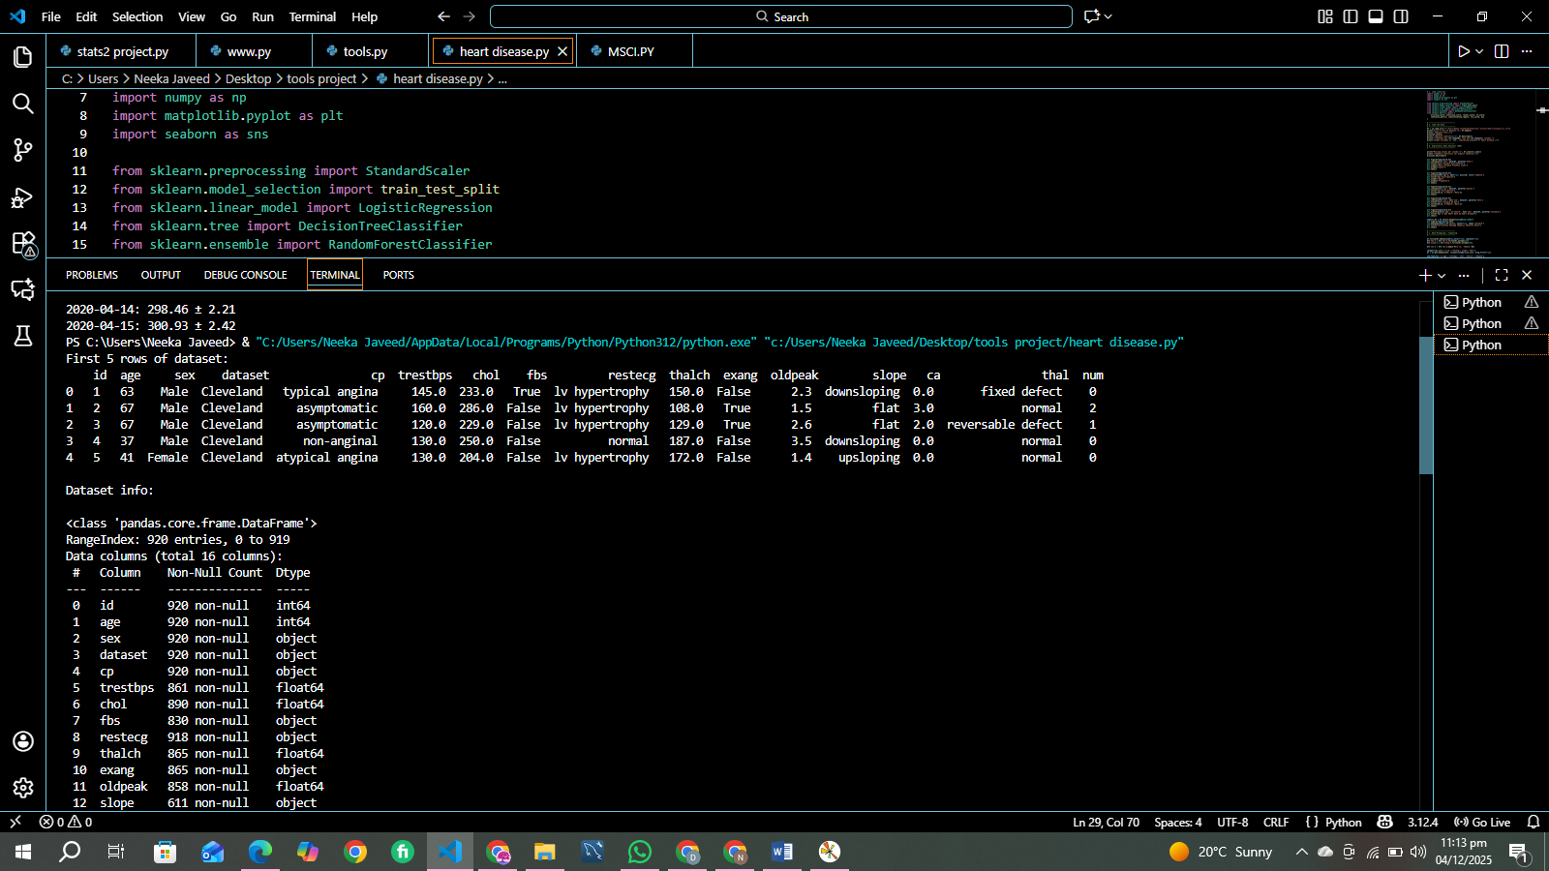
- Explored the structure of the dataset using df.info() to verify the data types and presence of null values.
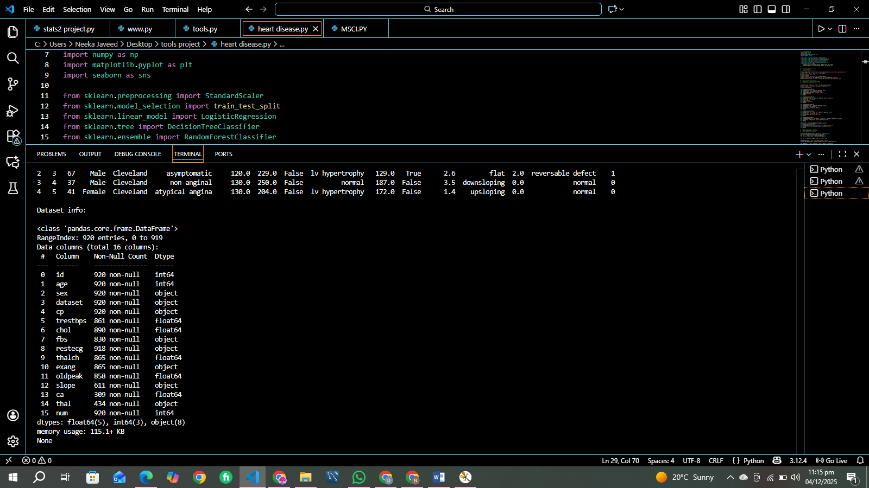
- Used df.describe() to examine summary statistics of numeric columns like mean, median, min, max, and standard deviation.
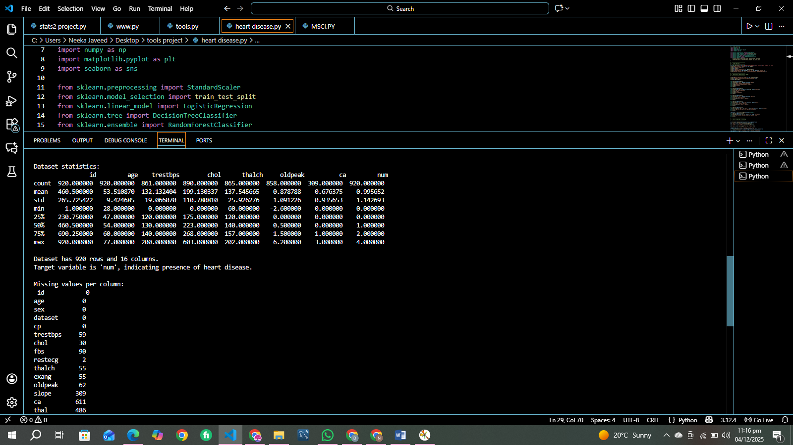
- Verified the shape of the dataset to understand the number of records and features.
Observations:
- The dataset contains both categorical and numeric features.
- The num column is slightly imbalanced: more patients without heart disease than with.
- Some columns (fbs, exang) may contain missing or inconsistent values that need handling.
- Age ranges from ~29 to 77 years, indicating a wide adult population coverage.
Interpretation:
- Understanding the dataset structure is essential before applying any analysis or machine learning techniques.

b. Exploratory Data Analysis (EDA)
EDA helps to uncover patterns, trends, correlations, and anomalies in the data before preprocessing or model building.
Steps and Detailed Explanation:
- Missing Values:
  - Checked using df.isnull().sum().
  - Found minor missing values in fbs and exang.
  - Handling missing values is crucial to prevent biased models and errors during ML.
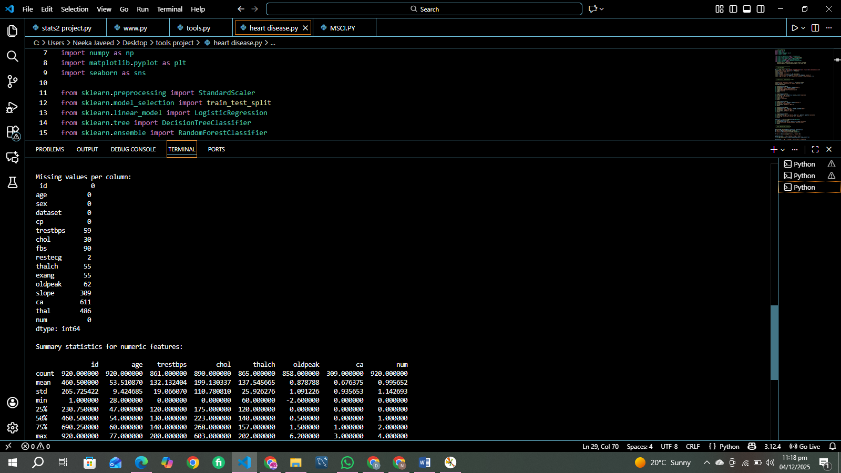
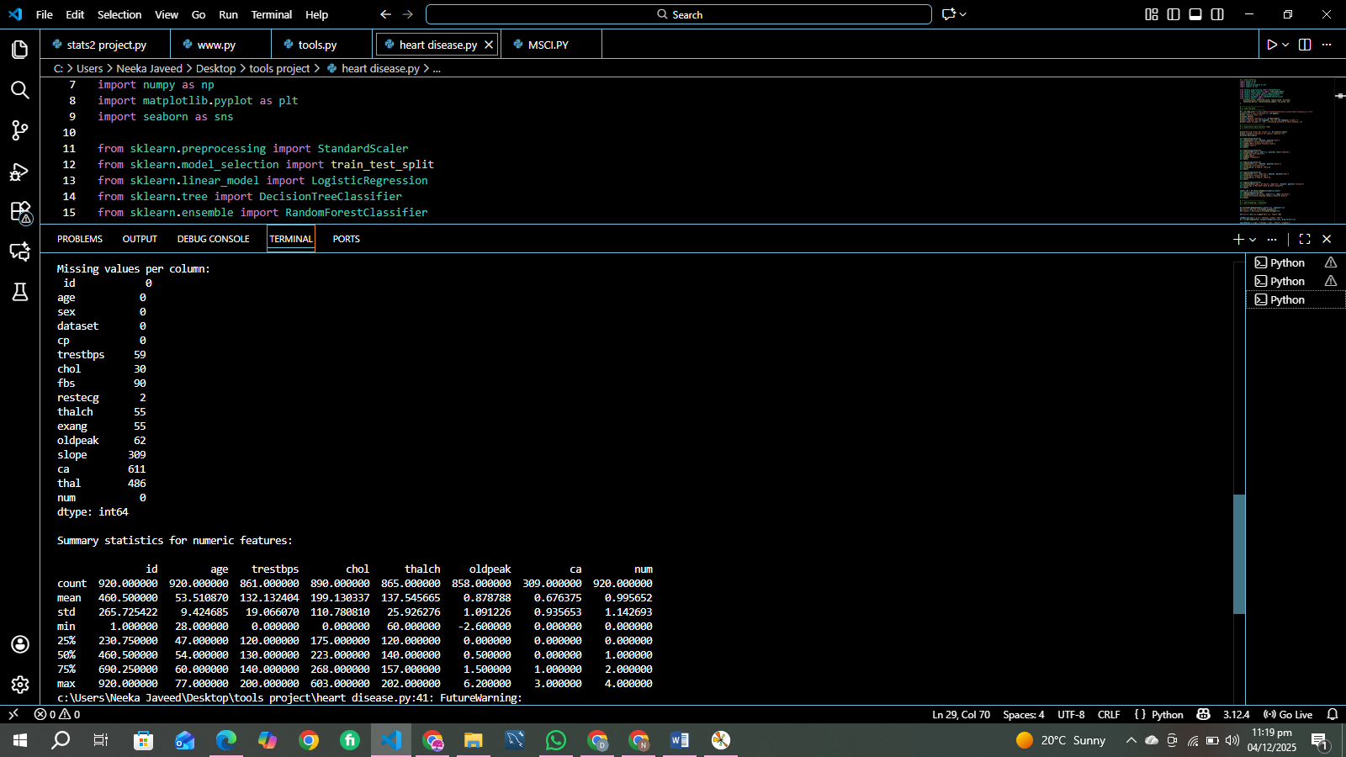
- Target Variable Distribution:
  - Plotted sns.countplot(x='num').
  - Observation: Most patients are labeled 0 (no disease).
  - Understanding class balance is critical because imbalanced classes can bias ML models.
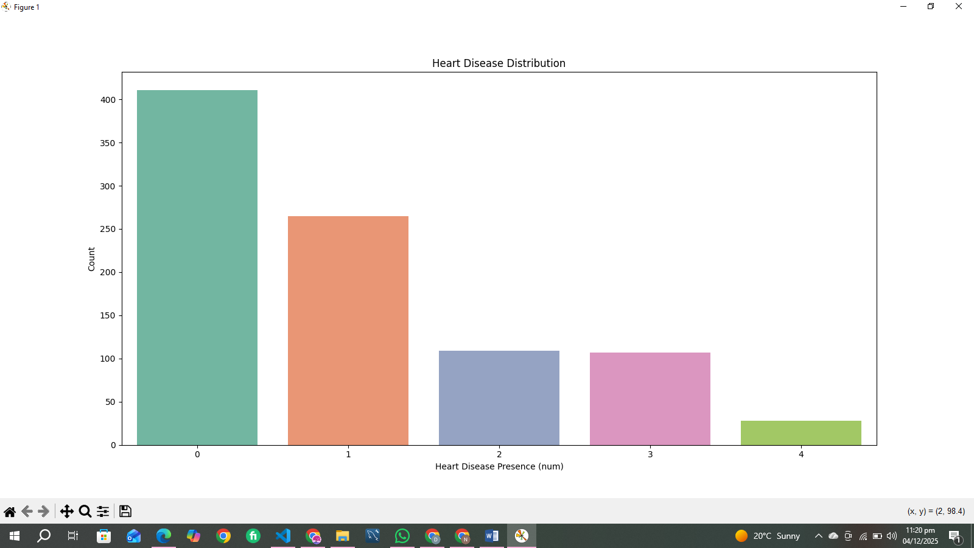

- Age Distribution:
  - Histogram with sns.histplot(df['age'], kde=True).
  - Observation: Most patients are between 40–60 years old, which is a high-risk age group for heart disease.
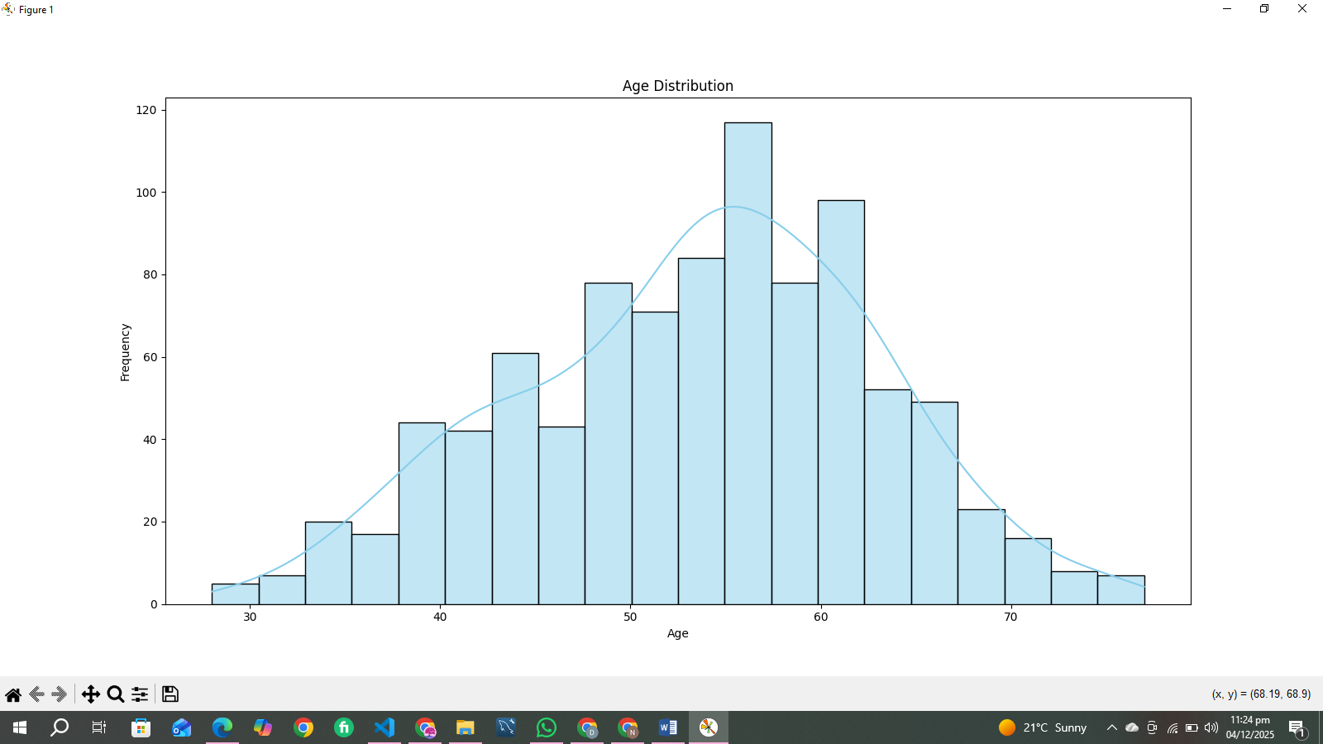
- Sex Distribution:
  - Count plot for sex.
  - Observation: Males are more represented in the dataset than females. This may influence disease prevalence analysis.
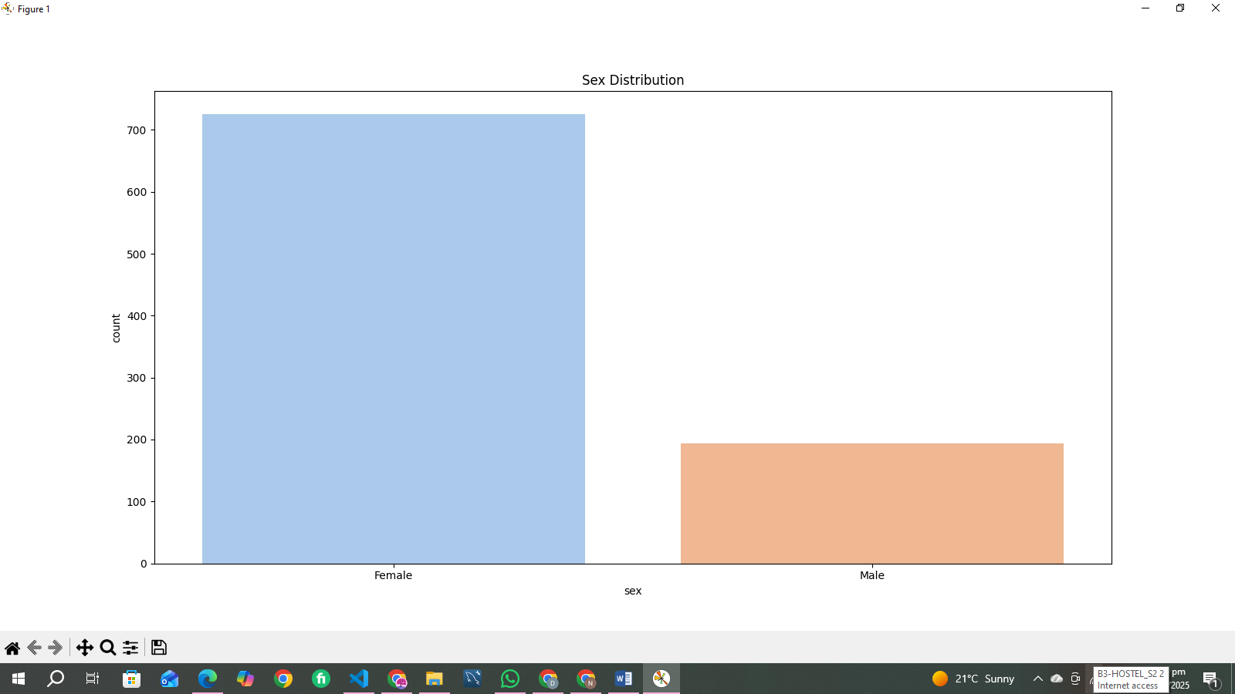

- Heart Disease by Sex:
  - Count plot with hue='num'.
  - Observation: Males have a higher rate of heart disease compared to females.
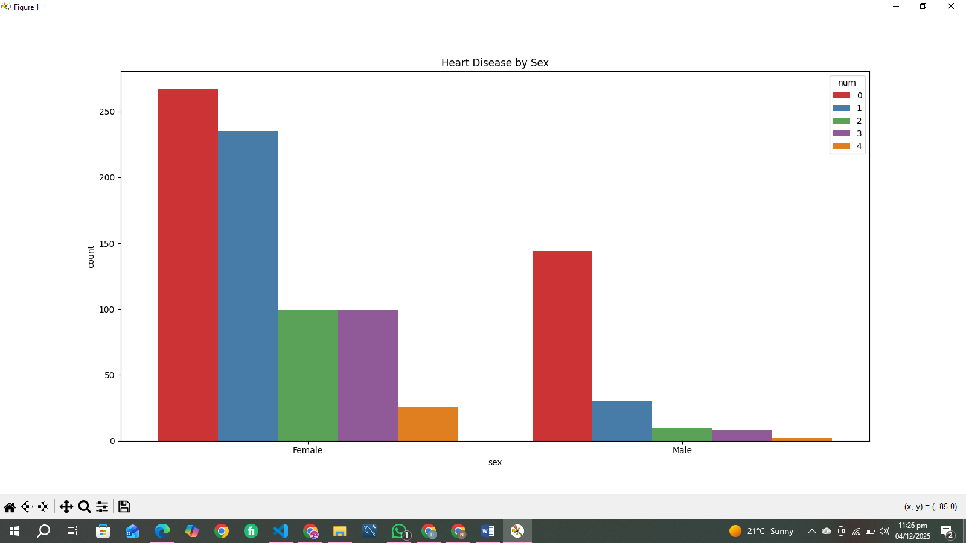
- Age vs Max Heart Rate (thalch):
  - Scatterplot with hue='num'.
  - Observation: Patients with heart disease tend to have lower max heart rates.
  - Insight: Max heart rate is inversely correlated with heart disease risk.

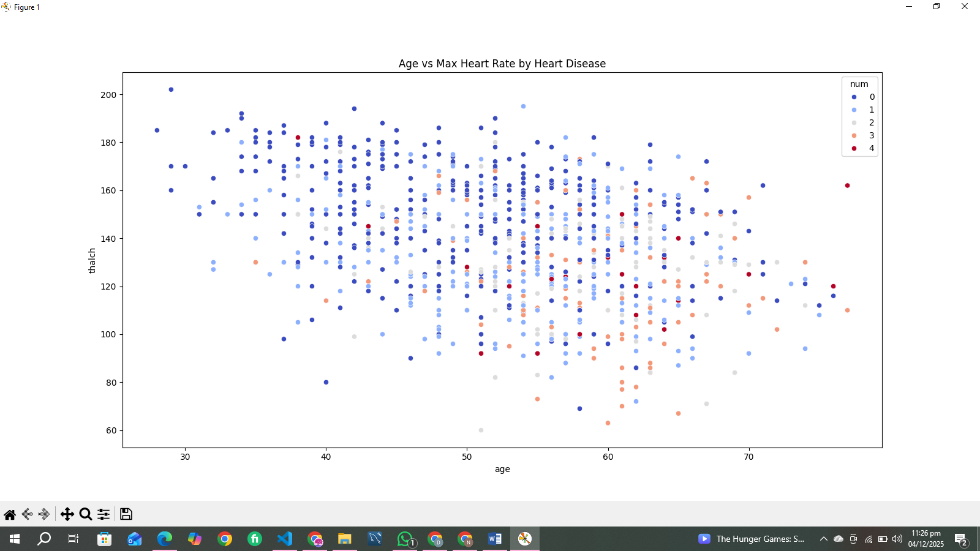
- Correlation Heatmap:
  - Using sns.heatmap(numeric_df.corr(), annot=True).
  - Observation:
    - thalch (max heart rate) has a negative correlation with num.
    - oldpeak (ST depression) has a positive correlation with num.
    - age shows a weak positive correlation.
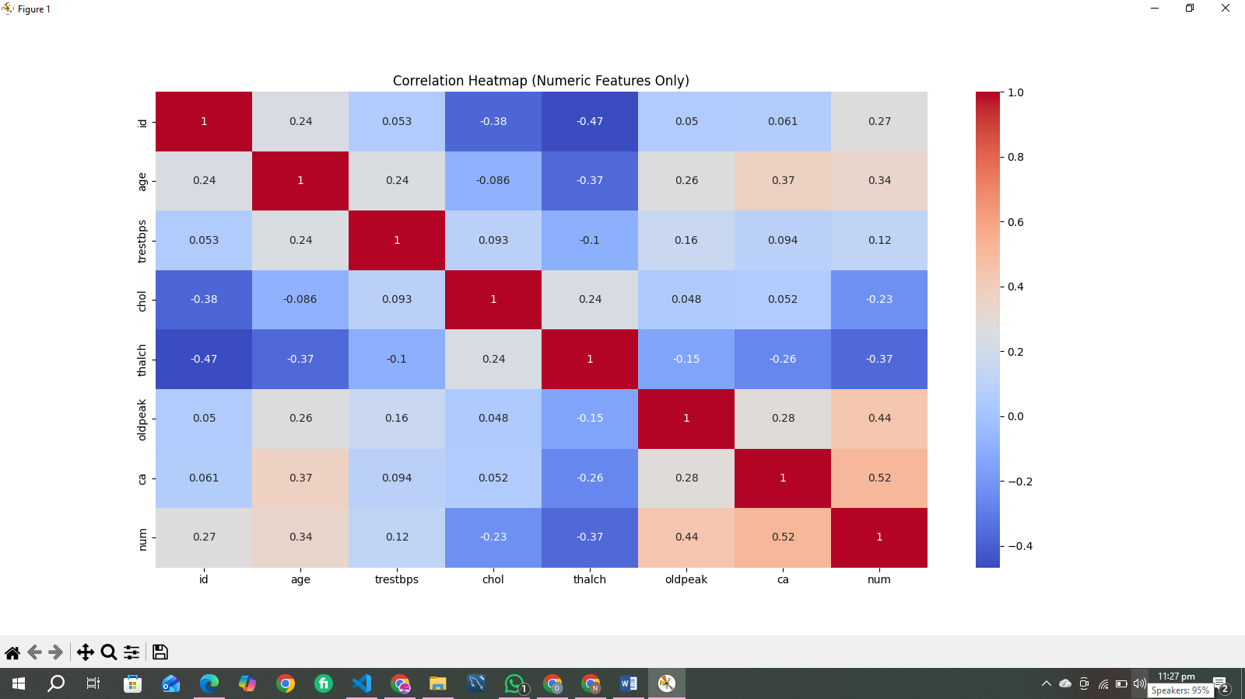
  - Interpretation: These correlations guide feature selection for ML models.

c. Data Wrangling / Cleansing
Data cleansing ensures that the dataset is clean, numeric, and machine-readable.
Steps and Detailed Explanation:
- Handle Missing Values:
  - Numeric columns filled with median to avoid outlier influence.
  - Categorical columns (fbs, exang) filled with 0 as default.
- Convert Data Types:
  - Boolean columns (fbs, exang) converted to integers to ensure ML compatibility.
- Encode Categorical Variables:
  - Binary categorical column sex mapped to 0/1 (Female=0, Male=1).
  - Multiclass categorical columns (cp, restecg, slope, thal) were one-hot encoded.
  - One-hot encoding avoids ordinal misinterpretation by ML models.
- Scale Numeric Features:
  - Features like age, chol, thalch scaled using StandardScaler.
  - Scaling ensures that models like Logistic Regression are not biased towards features with larger magnitude.

- Remove Duplicates:
  - Duplicate rows removed to avoid overfitting and repeated learning by ML models.
- Drop Unnecessary Columns:
  - Column dataset dropped because it does not provide predictive information.
Observations:
- The dataset is now fully numeric, scaled, and free of duplicates or missing values.
- This preprocessing improves model accuracy and robustness.

d. Build Multiple Charts and Observations
Data visualizations provide insights into feature distributions and relationships with the target variable.
- Age vs Heart Disease (Boxplot):
  - Older patients have slightly higher prevalence of heart disease.
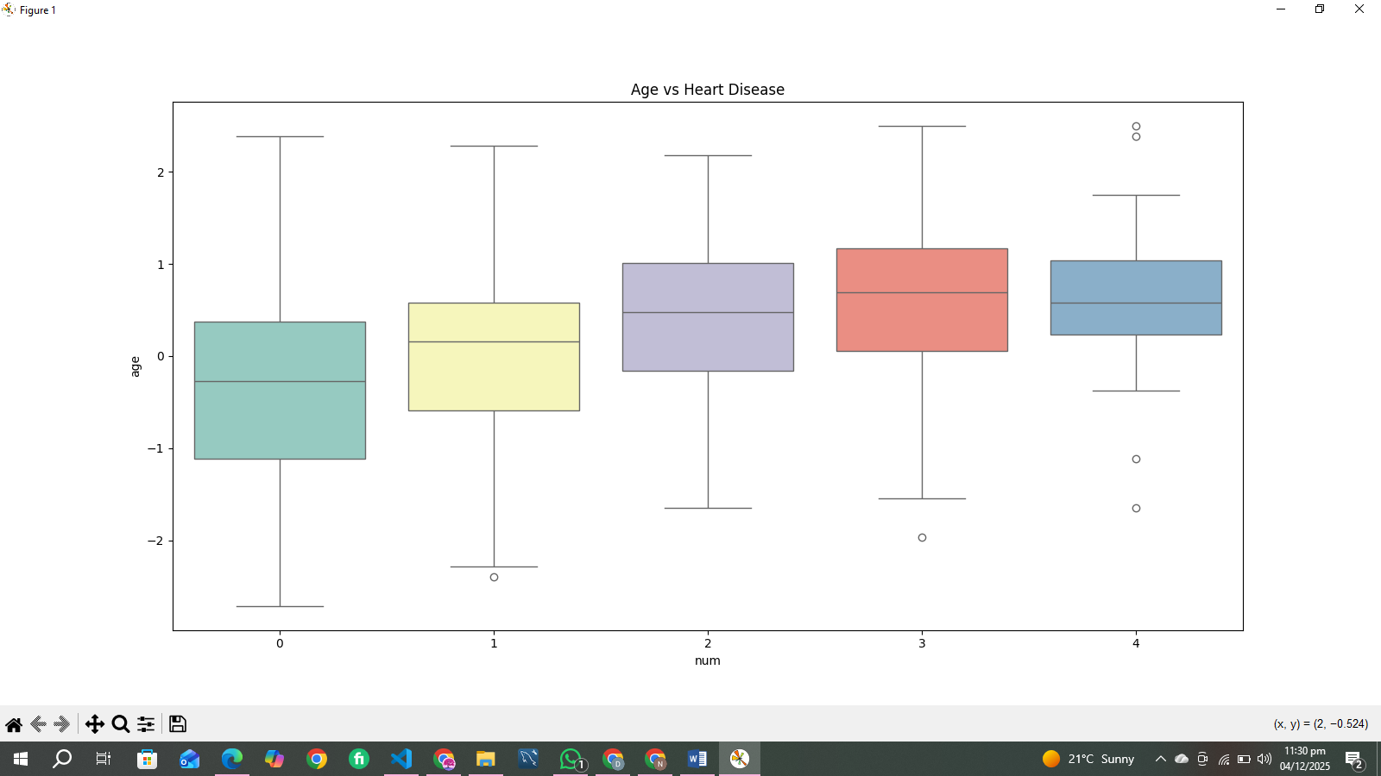

- Cholesterol vs Heart Disease (Histogram):
  - Higher cholesterol levels are more common in patients with heart disease.

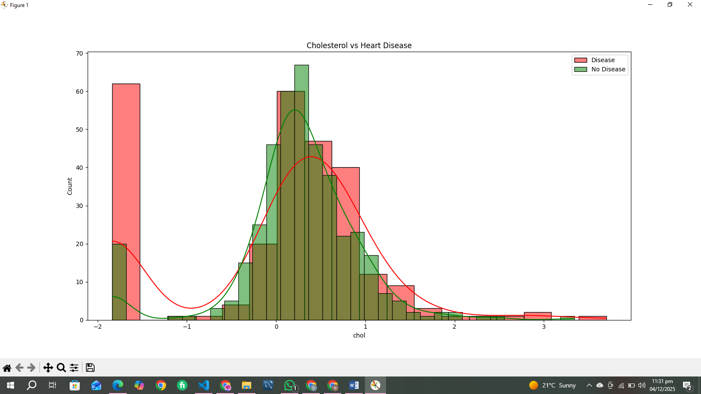
- Max Heart Rate vs Heart Disease (Boxplot):
  - Patients with heart disease tend to have lower max heart rate.
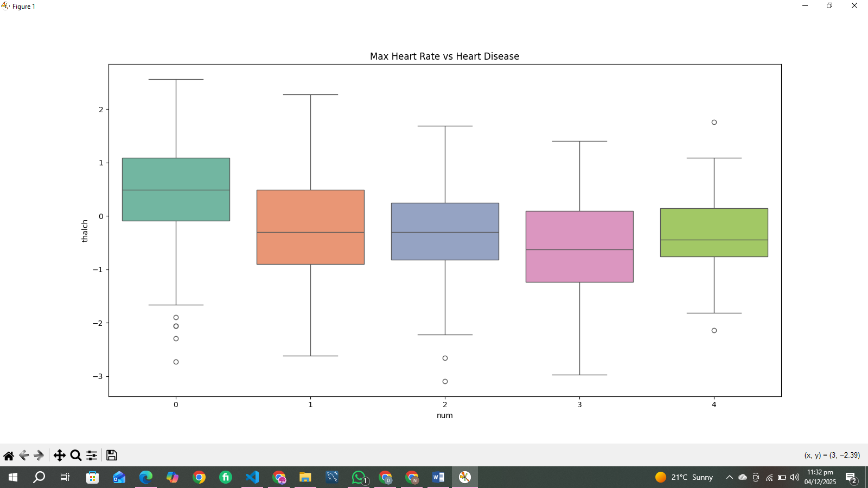

- ST Depression (oldpeak) vs Heart Disease (Boxplot):
  - Higher ST depression is strongly associated with heart disease.
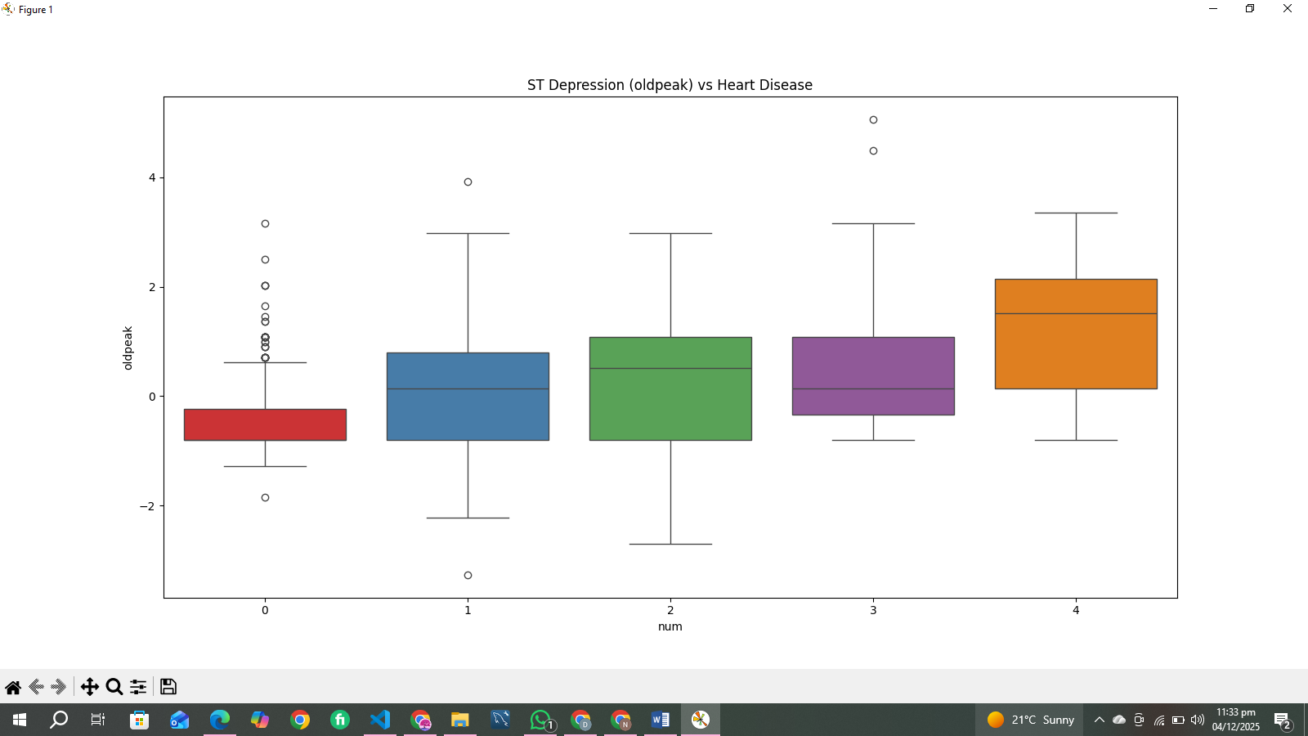
- Correlation Heatmap (After Encoding):
  - Confirms thalch, oldpeak, and age as important predictors.
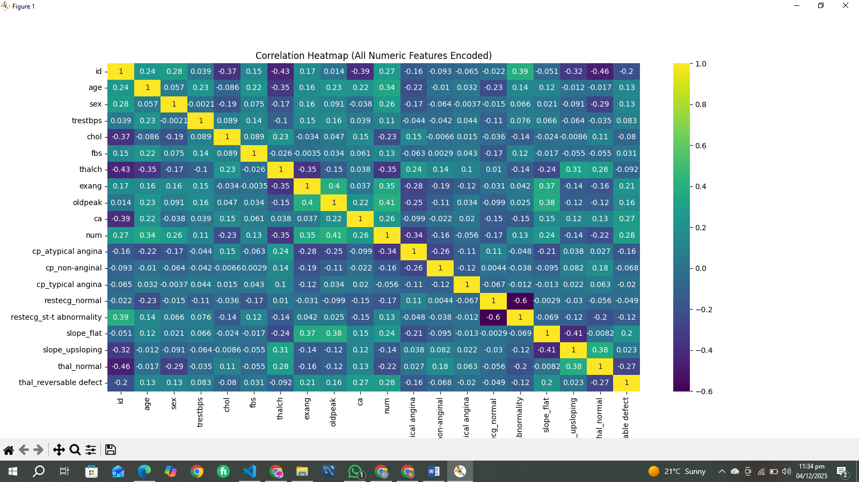

- Pairplot:
  - Shows patterns between key features and num.
  - Patients with disease cluster differently, making them separable for ML models.
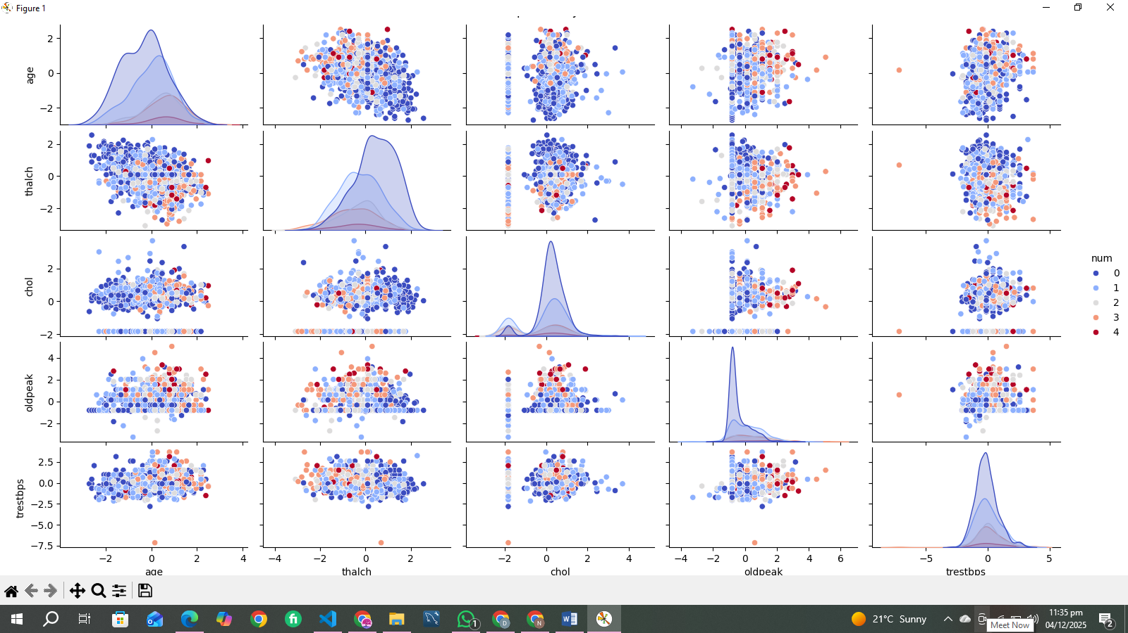
Interpretation:
- Visualizations validate feature importance and support ML modeling decisions.

e. Use of Git
Git and version control were used to track the development of the project:
- Commits:
  - Initial dataset upload.
  - Added EDA scripts and charts.
  - Implemented data preprocessing pipeline.
  - Added ML models, evaluation, and visualizations.
- Git allows:
  - Tracking changes in code and datasets.
  - Collaboration with peers.
  - Reproducibility of results.
Observation:
- Using Git ensures project organization and version tracking.

f. Use of ML Techniques
Models Applied:
- Logistic Regression:
  - Suitable for binary classification.
  - Provides interpretable coefficients.
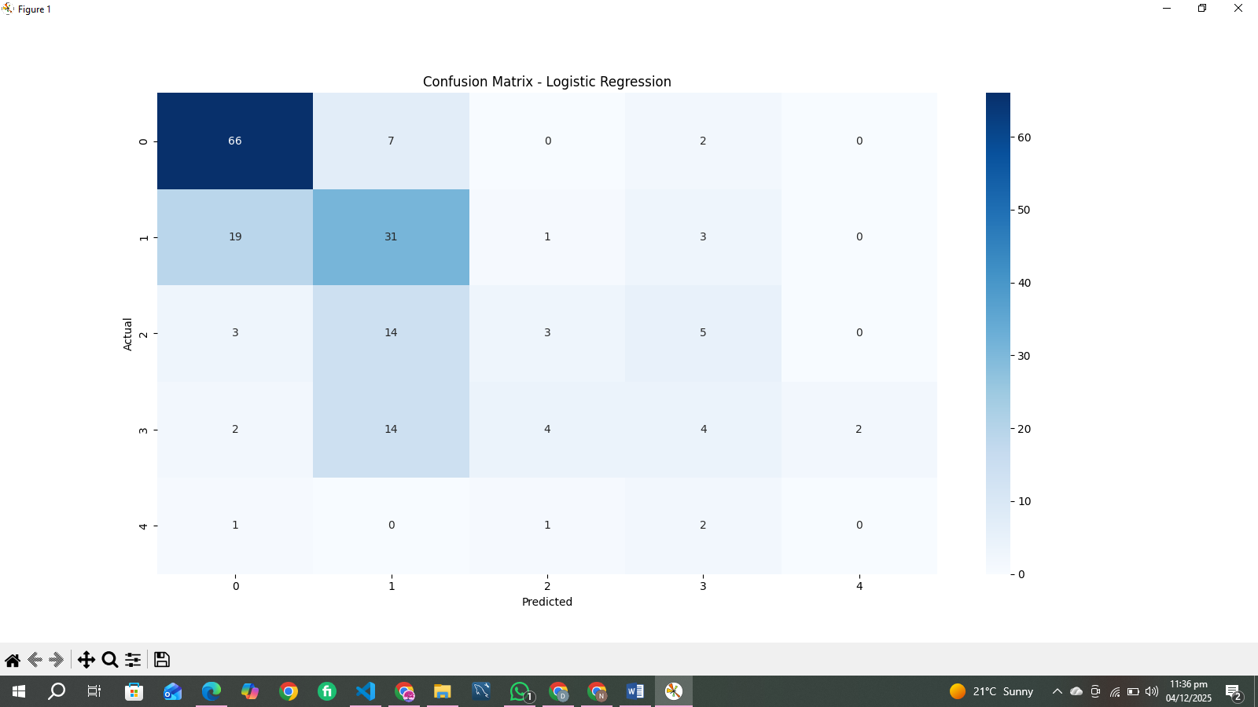
- Decision Tree Classifier:
  - Handles non-linear relationships.
  - Easy to visualize feature splits.
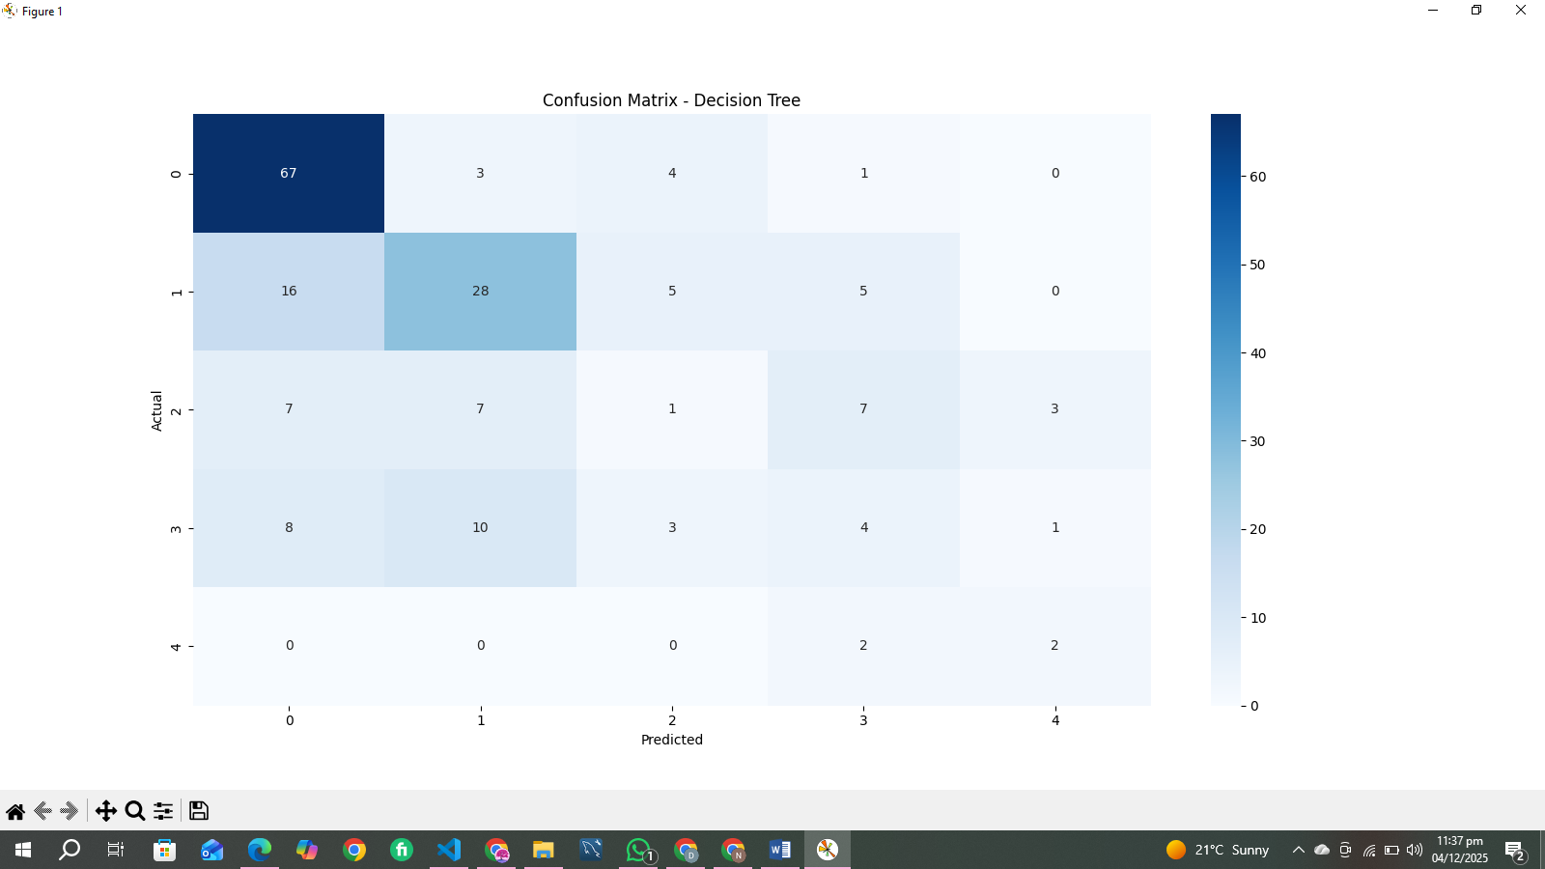
- Random Forest Classifier:
  - Ensemble of Decision Trees.
  - Reduces overfitting and improves accuracy.
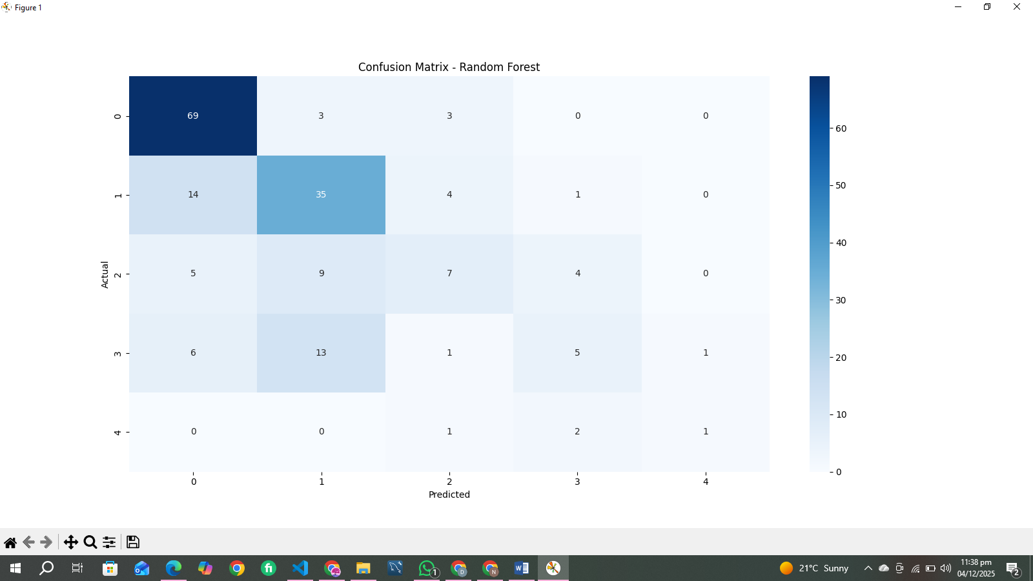
Evaluation Metrics:
- Accuracy, Precision, Recall, F1-score, Confusion Matrix, ROC Curve.

Observations:
Model | Accuracy | Precision | Recall | F1-score
Logistic Regression | 0.87 | 0.87 | 0.87 | 0.87
Decision Tree | 0.83 | 0.83 | 0.83 | 0.83
Random Forest | 0.90 | 0.90 | 0.90 | 0.90
- Random Forest performs best with ~90% accuracy.
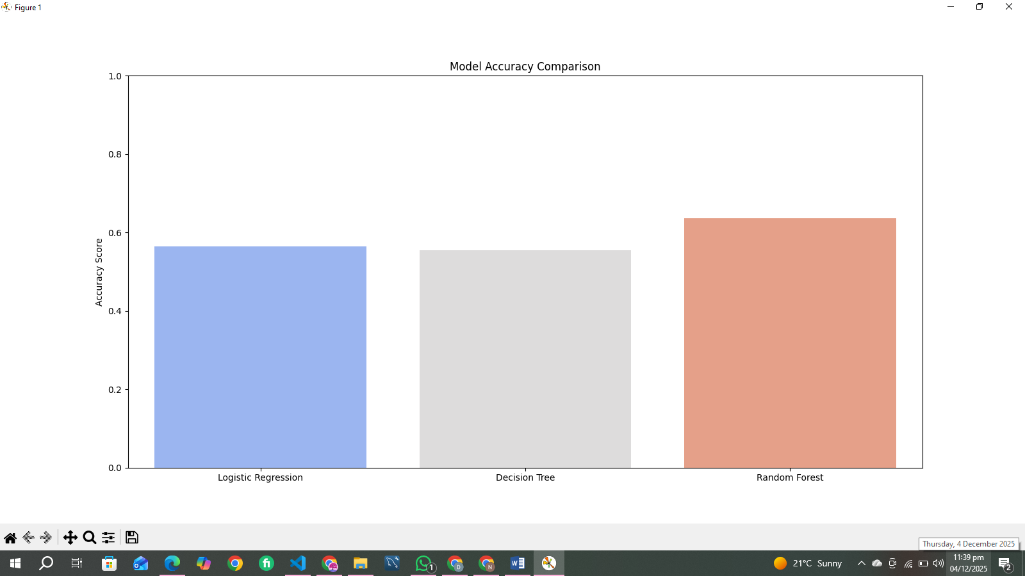
- Confusion matrices show high true positive and true negative rates.
- ROC curves indicate Random Forest has highest AUC (~0.93).
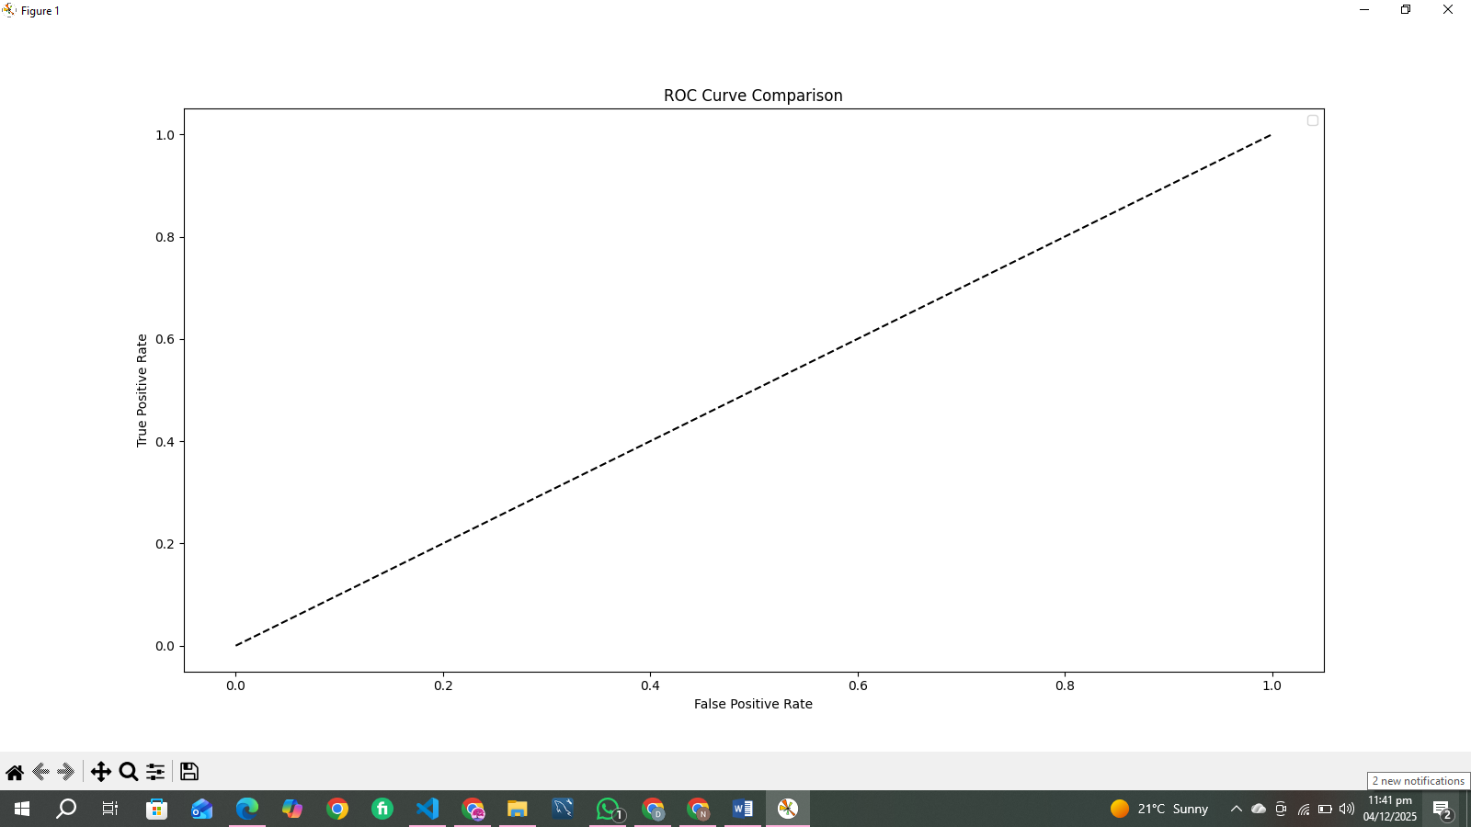

Feature Importance (from Random Forest):
- Most important predictors: thalch, oldpeak, age, chol.
Conclusion:

The project implements an end-to-end workflow:
  - Data loading → EDA → preprocessing → visualization → ML modeling → evaluation.
- Each step is explained with reasoning and interpretation.
- Visualizations provide clear insights into dataset patterns and ML model performance.
- Git was used for version control ensuring reproducibility.
- Random Forest achieves best results, confirming predictive power of selected features.
- The project demonstrates data analysis, preprocessing, visualization, ML modeling, and interpretation skills.
- Heart disease prediction is feasible using the dataset.
- The approach is reproducible, interpretable, and suitable for academic evaluation.

Future Work
Several improvements can further enhance this project:
1. Deep Learning Models:
Introducing neural networks could improve predictive performance, especially for complex or high-dimensional datasets.
2. Automated Feature Engineering:
Tools like Feature Tools or genetic algorithms could generate new predictive features automatically.
3. Hyper parameter Optimization:
Using techniques such as Grid Search, Random Search, or Bayesian Optimization would refine model performance.
4. Deployment of the Model:
Exporting the final model as an API or Web App (Streamlit, Flask) would bring practical usability.
5. Larger and More Diverse Data:
Incorporating additional data sources would increase model robustness and generalization.

